HTML and CSS

HTML

<DOCTYPE> identify doc as HTML type

hypertext markup language.

Used to describe content of webpage. Made out of elements using opening and closing tags.

In <head> we put settings of page.

In <body> is visible of page

NOTE - ! and TAB in VS code

Attribute –

Elements have attributes and they describe elements.

href=”link”

<img src =””>

< type=””>

* Classes and Id

Classes and Id are global attribute.

Used essentially to name element to select them in CSS to style them and in JS to select them to perform DOM manipulation.

ID needs to be unique

Classes name can be used over and over again.

CSS in next page

CSS

BOX model

It has – padding, width, height, border, margin

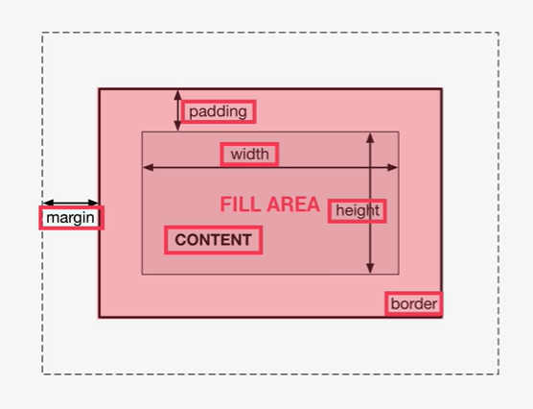

Content – text, img etc

Padding – transparent area around contents inside box

Border – Goes around padding and content.

Fill area – area that get filled with background color and background image

Margin – outside of BOX.

With ‘\*{}’ we can select all the elements on the page.